Project Report

LogHawk –
Cloud-Hosted Application Security Monitoring

This report documents the analysis of a simulated brute-force attack detected through authentication log monitoring on a cloud-hosted application deployed on AWS EC2.

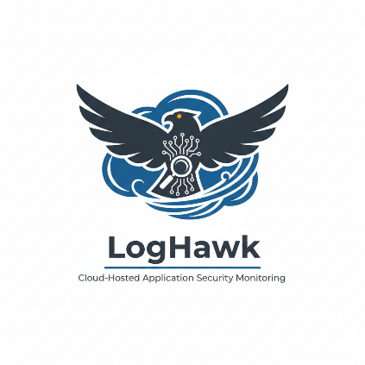

Prepared by:
Team member1 - Vishali
Team member2 – Sahibjot Singh
Date: 21/12/2025

Introduction

With the increasing adoption of cloud computing, applications hosted on public cloud platforms are often exposed directly to the internet. While this improves accessibility and scalability, it also increases the attack surface and makes applications vulnerable to common threats such as brute-force login attacks.
The objective of the LogHawk project is to demonstrate how a cloud-hosted application can be monitored for suspicious authentication activity using log-based analysis and SOC-style detection techniques. The project focuses on cloud security fundamentals, monitoring, and incident detection rather than complex application development.

Project Objectives

The main objectives of this project are:
- To deploy a web application on a public cloud platform
- To understand security risks associated with internet-facing cloud applications
- To generate and monitor authentication logs
- To detect brute-force attacks using threshold-based logic
- To simulate a SOC-style security monitoring and analysis workflow

Project Architecture Overview

The LogHawk project follows a simple and effective architecture:
- A web application is deployed on an AWS EC2 instance
- The server runs Ubuntu Linux
- The application exposes a login endpoint to the internet
- Authentication events are logged on the server
- A detection script analyses logs and generates alerts
This architecture reflects a real-world cloud workload where monitoring and detection are critical to maintaining security.

Cloud Environment Setup

Amazon Web Services (AWS) was selected as the cloud provider due to its wide industry adoption and availability of free-tier services.
An EC2 instance running Ubuntu Linux was created and configured with a public IP address. AWS Security Groups were used to control network access and allow only required ports:
- Port 22 – SSH access
- Port 80 – Web traffic
- Port 5000 – Flask application
This setup ensured controlled access while maintaining realistic cloud exposure.
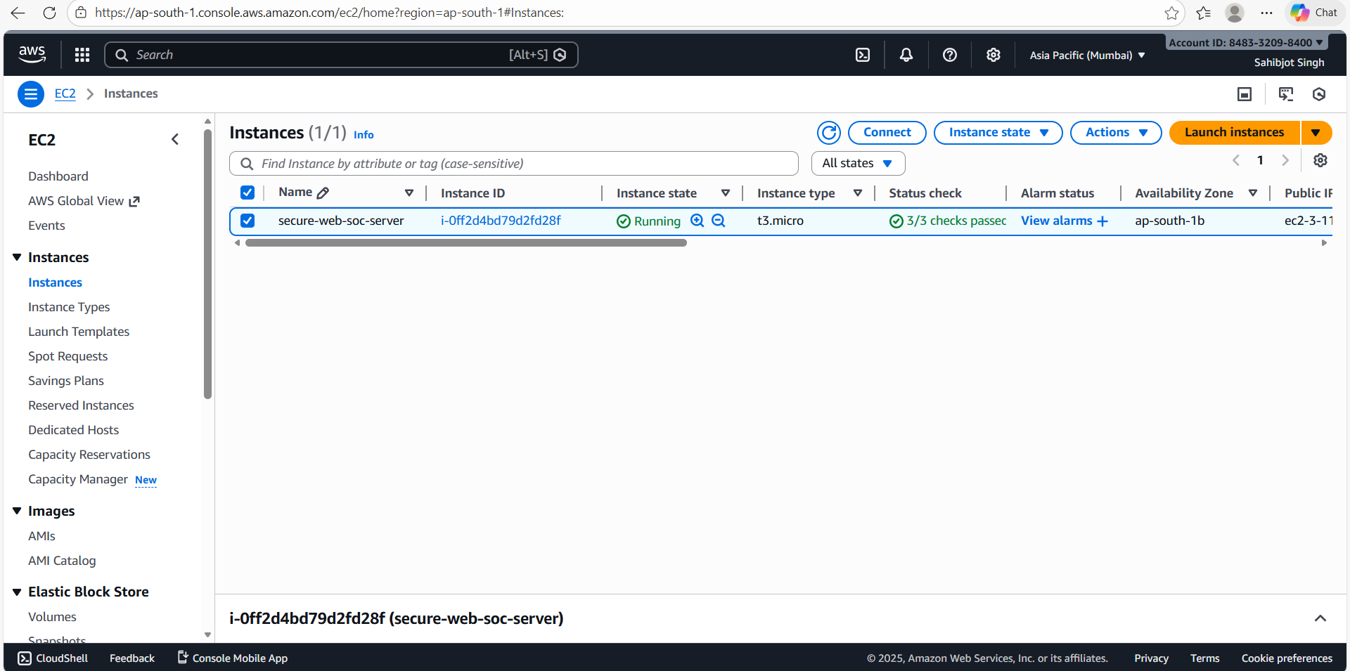

Secure Server Access (SSH)

Secure Shell (SSH) was used for encrypted remote access to the EC2 instance. Key-based authentication was configured to prevent unauthorized access and improve security.
SSH access allowed:
- Server administration
- Application deployment
- Log monitoring and analysis
Restricting and monitoring SSH access is an important aspect of cloud security, as compromised administrative access can lead to full server control.

Web Application Deployment

A lightweight web application was developed using the Flask framework. The application provides a simple login interface and runs on the EC2 instance.
The purpose of the application is not to act as a production system, but to generate realistic authentication activity that can be logged, monitored, and analysed from a security perspective.
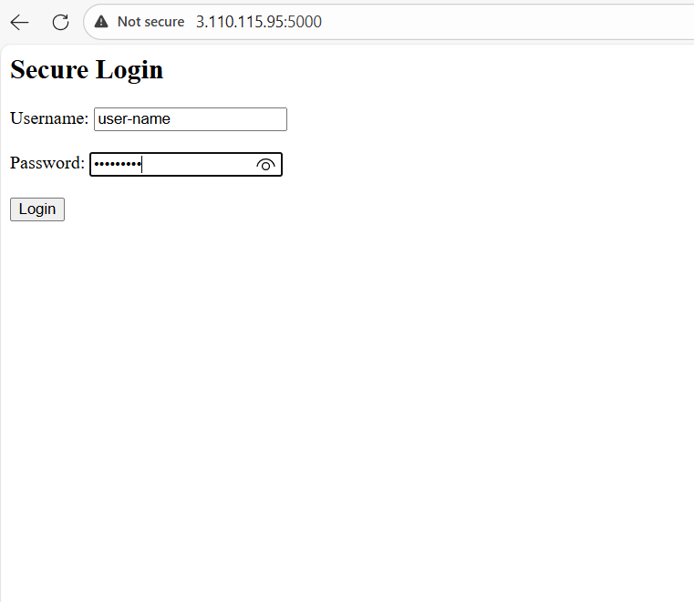

Authentication Logging Mechanism

Authentication logging was implemented within the application to record all login attempts.
Each log entry includes:
- Username entered
- Source IP address
- Timestamp of the attempt
These logs are stored in an authentication log file (auth.log) on the server and form the primary data source for security monitoring.
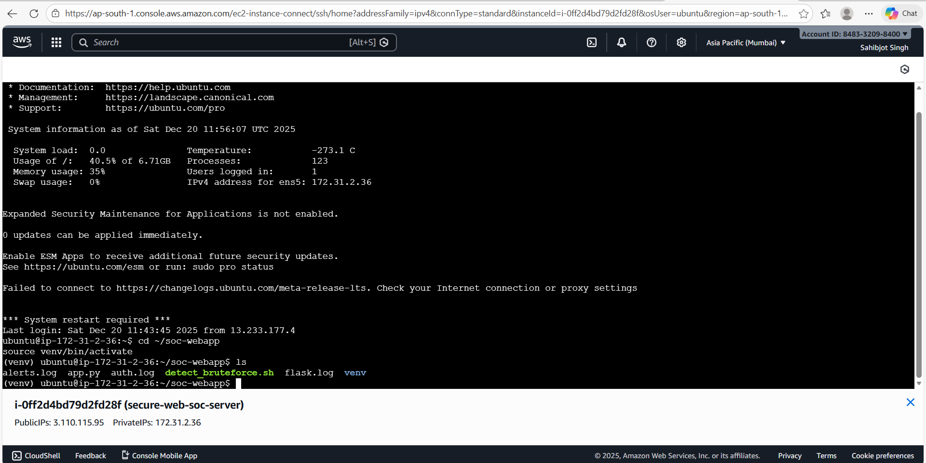

Log Monitoring and Detection

Authentication logs were monitored both as stored evidence and in real time using standard Linux log monitoring commands.
A Bash-based detection script was implemented to analyse recent log entries. The script applies a threshold-based rule to identify abnormal login behaviour, such as repeated login attempts within a short time period.
When the threshold is exceeded, the activity is classified as suspicious.

Alert Generation

Upon detecting suspicious activity, an alert is generated and written to an alert log file (alerts.log).
This alert acts as a notification for further investigation and simulates the alerting functionality commonly found in SIEM platforms. While simplified, this approach demonstrates the core logic behind SOC alert generation.
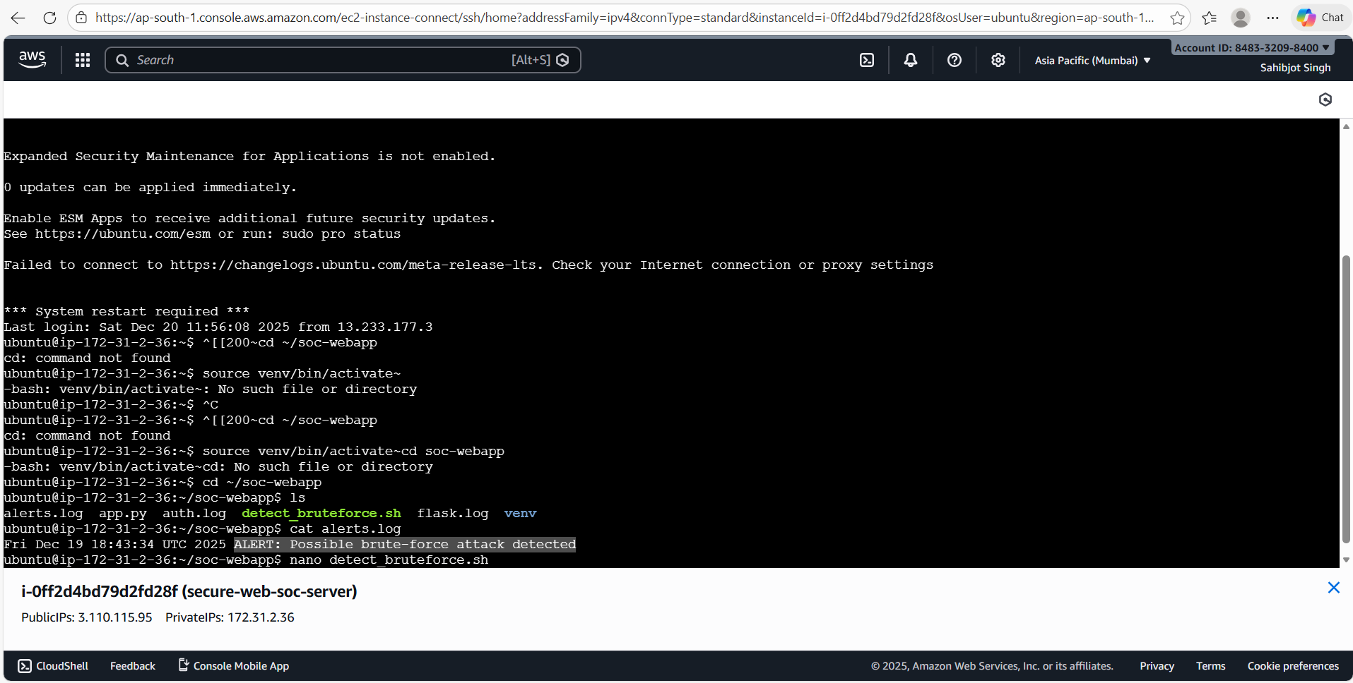

Security Analysis

The project highlights several important cloud security considerations:
- Public cloud applications are frequent targets for brute-force attacks
- Authentication logs provide valuable visibility into attacker behaviour
- Simple detection logic can effectively identify suspicious patterns
- Monitoring and validation are critical before taking response actions

Limitations of the Project

While the project demonstrates key security concepts, it has some limitations:
- No enterprise SIEM platform is used
- Automated response actions such as IP blocking are not implemented
- Detection is based on a single threshold rule
These limitations were intentionally kept to maintain clarity and focus on fundamentals.

Future Enhancements

Future improvements to the project may include:
- Time-window and per-IP–based detection rules
- Automated attacker IP blocking
- Centralized log aggregation
- Integration with SIEM platforms such as Splunk or ELK
- SOC dashboards for visualization

Conclusion

The LogHawk project successfully demonstrates how a cloud-hosted application can be monitored for authentication-based attacks using log analysis and SOC-style workflows.
Through this project, key skills in cloud security, log monitoring, threat detection, and incident analysis were developed. The project serves as a strong foundation for understanding real-world SOC operations in cloud environments.

Collaboration Responsibilities
This project was developed collaboratively, with responsibilities divided as follows:

Vishali
- Security monitoring and log analysis
- Design and implementation of brute-force detection logic
- Alert generation and validation
- SOC-style incident analysis and reporting
- Documentation of SOC analysis and security findings

Sahibjot Singh
- Cloud infrastructure setup on AWS EC2
- Server configuration and application deployment
- Flask application setup and authentication logging
- Initial environment preparation and testing

